**ALX AICE: Milestone #4 Worksheet**

| **Simulation Recap** |
| --- |
| This week, you accomplished several tasks related to the development of the updated version of VacAI. Firstly, you conducted thorough research and analyzed the data before creating the app prototype. Additionally, you created a user persona that guided your design thinking process for the app. Furthermore, you developed a landing page for the new update. Lastly, you concluded the week by sending a clear and concise email to the stakeholders at Waga, preparing them for the presentation you will be delivering next week.  Please follow the steps and instructions to complete the milestone successfully.  **Tip:** [**Check out the rubric**](https://docs.google.com/document/d/1HgGXVW1E2zt4qf1byxEHy86VNU1X7lEpiqUBGqlibeQ/copy) **before submitting your Milestone Worksheet.** |

# SECTION Zero

**Step 0: Completed Survey**

Complete the placement survey by [clicking here](https://theroom.formstack.com/forms/placement_l3?utm_source=lms&utm_medium=aice). After completion, take a screenshot of the thank you page and paste it below. Once done, go back to Savanna to continue your learning journey.

***To take a screenshot on Windows, use Alt + PrtScn***

***To take a screenshot on Mac, use Shift + Command + 5***

***You can use Ctrl + V or Command + V to paste the screenshot in the box below.***

Kindly complete the [survey by clicking here.](https://theroom.formstack.com/forms/placement_l3?utm_source=lms&utm_medium=aice)

**Step 0: Completed Survey**

|  |
| --- |

# SECTION A: Visualized Data

**Step 1: Visualized Data**

To complete this activity, you need to access the ["UN Data on Refugees (AiCE <> Dataset)"](https://docs.google.com/spreadsheets/d/12ELmgxSyxIAr54tpoNJFIbDdK8kdYfMf_2I1s43a1AY/copy) dataset and make sure you have visualized the data given to you.

*To do this:*

First, find the total number of refugees in each country using Tab 1 (Data) Tab.

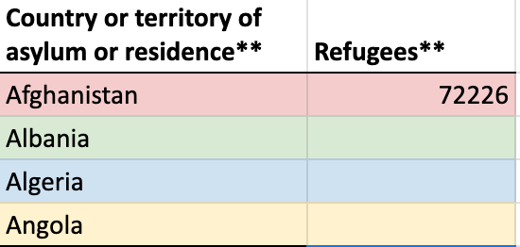

Once you have done that, make sure you have visualized the data using a Bar Chart, Pie Chart [(Activity: Visualize Your Dataset (Part A))](https://intranet.alxswe.com/concepts/102401), and your visualized data from Julius AI [(Activity: Visualize Your Dataset (Part B))](https://intranet.alxswe.com/concepts/102402).

After that, you need to paste the link to the copy of your worksheet. Please ensure that the link you are pasting can be viewed by anyone, and the setting should be set to "anyone with the link can view."

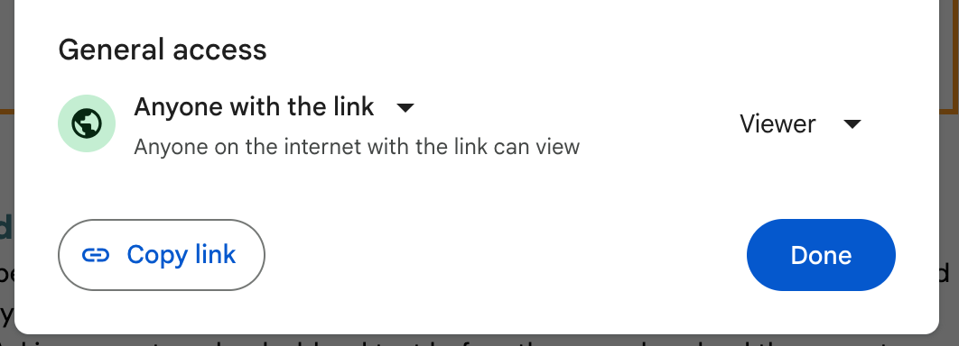

**Step 1: My Visualized Data**

| [UN Data on Refugees (AiCE <> Dataset)](https://docs.google.com/spreadsheets/d/1uxqHaX6QcUsq0xcWLbo_ZV_LBWWus9tP0npSWVN6-Co/edit?usp=sharing) |
| --- |

# SECTION B: User persona

**Step 2: User persona**

Paste the links to both user personas from this activity in the box provided below, and ensure your user persona has the correct file name.

The user persona was created manually with Canva, in Part A of this activity: [Create Your User Persona](https://intranet.alxswe.com/concepts/102349)

**Step 2a: Manually Created Userpersona**

| [Manually Created Userpersona.png](https://drive.google.com/file/d/1mupg4LuE4iHBX14eUNJkb3EpTc2S_H0C/view?usp=sharing) |
| --- |

The user persona was created with user persona dev in Part B of this activity: [Create Your User Persona](https://intranet.alxswe.com/concepts/102349)

**Step 2b: AI Created Userpersona**

| [AI Created Userpersona.png](https://drive.google.com/file/d/119X9IxurUqPaJDf_Wx5KpOTPaH61zMoo/view?usp=sharing) |
| --- |

# SECTION C: Before Your Peer Meeting

**Step 3: Restate your problem statement**

Please write your problem statement from week 2 here *(This is the problem statement you wrote based on your simulation activity at Waga).*

**Step 3: My Problem Statement**

| **Problem description** - The Failed launch of VacAI used by customers for checking the availability of hotel service, location information is inefficient and prone to errors.  **Identifies the population** - The customers of VacAI across all over the world are impacted by the ineffective information system.  **States the impact of the problem** - The inefficiencies in the information system result in decreased app usage and downloads due to inefficiencies and potential old information Moreover, the inconsistency in hotel schedules affects customers, the hotel business firm, and the local tour guide community, leading to decreased income and potential turnover.  **Identifies a gap between the current state and the desired/solved state -** There is a significant gap between the present information database system and the desired outcome of a streamlined, user-friendly customer experience. |
| --- |

**Step 4: Bad Idea Brainstorm**

BEFORE your peer meeting, conduct a Bad Idea Brainstorm with yourself. List at least 10 bad ideas for how you might solve the failed launch of VacAI. You can get completely ridiculous. For example: Asking users to upload a blood test before they can download the app, etc. The dumber the idea, the better! The purpose of this is to get your mind open to generating ideas without fear of them being wrong, dumb, or bad. (Stay in divergent thinking.)

Need help? Click **“Give Me a Bad Idea**” on this website <http://labs.jackpine.co/projects/FirstBadIdea/> to get some inspiration.

**Step 4: Bad Ideas**

| 1. **VacAI Vacation Roulette:** Instead of showing availability, VacAI picks random hotels and flights for the user based on their travel spirit. This injects surprise into the planning process, ignoring user preferences and potentially landing them in undesirable locations. 2. **Vacation by Emoji:** Ditch the search bar! Users express their ideal vacation through a series of emojis (palm tree, mountain, etc.) The AI interprets these and suggests destinations with zero text descriptions, promoting complete confusion. 3. **Celebrity Endorsement Extravaganza:** Hire a spokesperson notoriously bad at travel planning (think someone who gets lost easily) to endorse VacAI. Their chaotic testimonials will surely instill confidence in users. 4. **Pay-Per-Click Hotels:** Instead of showing availability, VacAI displays only hotel names. Users click on each one, paying a small fee to reveal availability and basic information. This monetizes frustration and wastes user time. 5. **Travel by Horoscope:** Forget dates and budgets! VacAI generates itineraries based on the user's astrological sign. Geminis get a whirlwind Vegas trip, Leos get a luxurious glamping experience (regardless of their budget). 6. **The "Guess the Location" Game:** VacAI shows stunning vacation photos with absolutely no information about the location or cost. Users can pay to enter guesses, with only the winner (if any) learning the actual destination. 7. **VacAI Vacation Vloggers:** Hire a group of overly enthusiastic, but completely unqualified travel vloggers to showcase random tourist traps based on AI suggestions. Their biased, obnoxious reviews will surely inspire wanderlust. 8. **The "Everything Is Booked" Filter:** This filter shows every single location and hotel as completely booked, regardless of availability. Users are left feeling defeated and questioning their entire vacation dream. 9. **The "Anti-Guide":** VacAI actively discourages travel by showing every potential downside of a user's chosen destination – bad weather, inconvenient transportation, local customs they might find strange. 10. **VacAI Vacation Pen Pal Program:** Instead of booking, users connect with a travel pen pal in their desired location. They must exchange letters for weeks, hoping to get basic information about the place before even considering a trip. |
| --- |

**Step 5: Possible ideas**

Next, list at least 5 “possible ideas” to address the problem with VacAI. These do NOT have to be good ideas. The only constraint is that they should just be at least theoretically possible. It could be adding a simple user onboarding process or introducing an entirely new dashboard. You’re still in Divergent thinking here, so don’t judge your ideas as good or bad.

**Step 5: Possible Ideas**

| 1. **VacAI VR Vacation Test Drive:** Users wear a VR headset and experience a 360-degree simulation of potential vacation destinations based on their preferences. This could be impressive, but might not be feasible for everyone and could cause motion sickness. 2. **AI Travel Buddy Integration:** VacAI integrates with a social AI companion app. This AI friend chats with users, offering quirky travel advice and potentially becoming annoying or missing the mark on user desires. 3. **Live Hotel Availability Auction:** VacAI hosts a real-time auction system for hotel rooms. Users bid against each other for the best deals, potentially leading to bidding wars and frustration if competition is high. 4. **Hyper-local Itinerary Customization:** VacAI taps into local social media feeds and reviews to personalize itineraries in real-time. This could offer unique experiences, but might also include biased or inaccurate information. 5. **VacAI Travel Karma Points System:** Users earn "karma points" for positive reviews, completing travel challenges, and using the app frequently. Points can be redeemed for discounts or exclusive experiences, but could create a gamified system that feels inauthentic. |
| --- |

# SECTION D: PEER Meeting Output

**Step 6: Meeting Date, Time, & Location**

Please list when and where your team meeting took place.

**Step 6: Meeting Date, Time, & Location**

| 1. Date: 04-03-2024 2. Time: 4:01PM - 4:49PM 3. Location: *Zoom* 4. Peer Name: Peter Kebet |
| --- |

**Step 7: Selected Solution**

Choose and specify the idea you are going with.

**Step 7: Selected Solution**

| **The Selected Solution was the Final Proposed Solution which is:**  **Integrating Karma Points feature:** Users earn karma points for positive reviews, completing travel challenges, and using the app frequently. Points can be redeemed for discounts or exclusive experiences. |
| --- |

**Step 8: Peer's Feedback**

Please state which idea your peer found the most appealing during the conversation and explain the reason for their choice.

**Step 8: Peer's Feedback**

| My peer also has agreed on my selected solution. He believes that Integrating Karma points would make customers spend more time on the app for the intention of getting more points for discounts and discounts might lead peoples to make plan for their next vacation in short time. |
| --- |

**Step 9: Reflection**

In a brief paragraph, describe your experience with peer coaching, including what went well and areas for improvement.

**Step 9: Reflection**

| I had another amazing peer coaching session with my Peer Mr. Peter. As he was the previous time, He is still an open-minded, funny and very humble person. I like the whole conversation. And nothing has to be improved as mentioned in our conversation. |
| --- |

**Step 10: Email to Stakeholders**

Paste your email from the [Activity on email writing to stakeholders](https://intranet.alxswe.com/concepts/102403) in the box below.

**Step 10: Email to Stakeholders**

| **Subject: Progress Update: VacAI Relaunch and Final Solution**  **Dear WAGA Stakeholders,**  I hope this email finds you in good spirits. I am pleased to provide an update on the progress of the relaunch of VacAI, our innovative travel app. Throughout the week, our team has been diligently exploring various ideas to enhance user experience and engagement. Here is a summary of the generated ideas:   1. **VacAI VR Vacation Test Drive:** We considered offering users a virtual reality experience to explore potential vacation destinations. However, we recognized potential limitations such as feasibility and motion sickness concerns. 2. **AI Travel Buddy Integration**: Another idea involved integrating VacAI with a social AI companion app to provide personalized travel advice. However, there were concerns about the AI potentially missing user preferences or becoming annoying. 3. **Live Hotel Availability Auction**: We explored the concept of a real-time auction system for hotel rooms within VacAI. While it could offer users competitive deals, we acknowledged potential frustrations with bidding wars. 4. **Hyper-local Itinerary Customization:** An idea involving leveraging local social media feeds and reviews to customize itineraries in real-time. While promising for unique experiences, there were concerns about biased or inaccurate information. 5. **VacAI Travel Karma Points System:** Finally, we proposed a travel karma points system where users earn rewards for positive engagement. We believe this solution offers incentives for user participation without feeling overly gamified.   After careful consideration, we have decided to proceed with the fifth idea—the VacAI Travel Karma Points System—as our final proposed solution.  Reflecting on our experiences throughout the week, we found the brainstorming process invigorating yet challenging. While we encountered obstacles, such as balancing innovation with practicality, we also discovered exciting opportunities to enhance VacAI's value proposition.  I am pleased to inform you that significant updates have been made to VacAI, and I will be sharing the prototype in a presentation document during our next meeting. Your feedback and insights are invaluable as we continue to refine VacAI and deliver an exceptional travel experience to our users.  Thank you for your continued support and collaboration.  Best regards, **Habtamu Wolde** Senior Full stack Developer |
| --- |

**Step 11: AI Toolkit**

To access your AI Toolkit, Go to your personal ALX AICE Google Drive, then locate your updated [AI Toolkit Spreadsheet.](https://docs.google.com/spreadsheets/d/11HJQIo3FncvMSBTs4fZ413aPBSmLrhXnfoXx5dqoeqA/copy) Make sure your AI Toolkit is updated and contains prompts and workflow optimization processes from the following activities:

* Visualizing Data Using Julius AI
* User Persona
* Email to Stakeholders

Next, Click **"Share"** (under the 3 dots) and adjust the settings so that it looks like this:

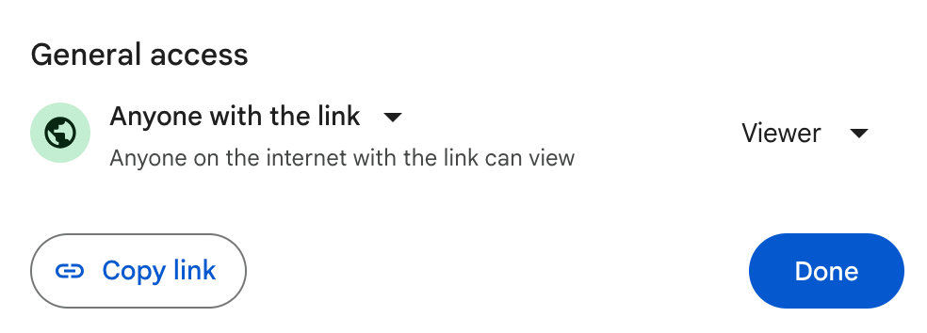

# **Then, copy the link and paste it in the box below;**

**Step 11: Your AI Toolkit**

| [AICE AI ToolKit_Habtamu_Wolde](https://docs.google.com/spreadsheets/d/1_lzTTNa11FUXXYNQqW-rTbZUhrh-9mqUyAPHh2iEo50/edit?usp=sharing) |
| --- |

*If you need more help with this, Google for video instructions on sharing files in Google Drive, or ask a peer.*

**Step 12: Reflection on the use of AI**

Take a moment to reflect on how you used AI this week, you are to write a short paragraph answering the following reflection questions:

**Reflection on the use of AI**

| 1. How did AI assist you in the writing process? Did it help you generate ideas, proofread, or edit your work?  2. Did you feel that AI helped you save time or improve the quality of your writing?  3. What potential drawbacks or limitations did you experience while using AI for writing?  4. How did you use AI for prototyping? Did it help you create and refine designs or models?  5. In what ways do you think AI can improve the prototyping process, and how might it be limited? |
| --- |

**Step 12: Write Your Reflection Response Here**

| 1. As a student exploring AI essentials, I've discovered its practicality in writing tasks. AI aids me in generating ideas when I'm stuck and assists in proofreading and editing my work, catching errors and suggesting improvements. Its support throughout the writing process enhances the quality of my work and boosts my productivity. 2. Absolutely, AI has significantly aided in both saving time and enhancing the quality of my writing. By automating proofreading tasks and providing valuable suggestions, it streamlines the writing process, allowing me to focus on the main task at hand. 3. While AI has been beneficial in many ways for writing, it does come with some limitations. One drawback is that AI tools may not always fully understand context or nuance, leading to inaccurate suggestions or corrections. Additionally, reliance on AI for writing tasks could potentially inhibit personal creativity and critical thinking skills. 4. In prototyping, I utilized AI (Uizard) to create and refine designs particularly in generating wireframes of Mobile applications. These tools enabled rapid iteration and exploration of various design options, saving time and effort. 5. AI offers immense potential to enhance the prototyping process by enabling rapid iteration, generating diverse design alternatives, and providing insightful analysis of prototypes.   However, AI's limitations include potential biases in design suggestions and the need for human oversight to ensure that AI-generated prototypes align with user needs and project goals. |
| --- |